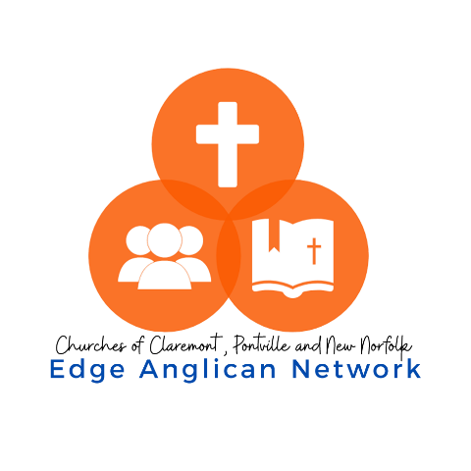

Position Description- Assistant Minister

Position Title
Full Time Assistant Minister – Edge Anglican Network.
Position Context
This is a full-time position.
The Assistant Minister will have responsibility for Site Ministry in New Norfolk and a Network Discipleship portfolio in the context of the Edge Anglican Network, it is anticipated that the successful candidate would live in New Norfolk.
New Norfolk has been identified as a church that needs re-vitalising. Bishop Richard Condie has flagged the desire and need for fresh ministry experiences and opportunities. In his first presidential address at Synod he wrote; “Disciple-making is a long process, that involves engaging people who know nothing of Jesus, sharing the good news with them, that is evangelising, then establishing them in the faith, teaching them to walk with Christ and then equipping them to replicate ministry wherever they go to serve.”
This position is a strategic element in the Bishop’s hope for Tasmania and is a crucial component in the establishing of a new local ministry network of three parishes supported by the Diocese, and Edge Anglican Church in Claremont.
Responsible To
The Senior Minister of the Edge Anglican Network, Rev Rob Craft and the Bishop of Tasmania.
Key Responsibilities
The successful candidate will be responsible for:
- Implementing gospel-centred and contextually sensitive ministry initiatives in the Edge Anglican Network, with a specific site focus in New Norfolk. (Tit 1:5)
- Equipping, enabling, training and facilitating church members, prayerfully identifying and encouraging people into areas of ministry that they are gifted in. (Eph. 4:12)
- Regularly preaching and teaching
- Working closely with the Edge Senior Network Minister, as the direct supervisor, to develop a ministry plan and implementing that plan within a new five-year strategic vision, formulated by the Network.
- Launching a new contextually appropriate afternoon congregation in New Norfolk in consultation with external stakeholders as necessary and the Senior Minister

Key Tasks Include:
- Praying and studying the Scriptures
- Teaching the Bible correctly and pastorally
- Leading and managing a church site.
- Caring for people in the church
- Protecting the church from false teachers and teaching
- Discipling and nurturing church members.
- Developing other leaders and teachers and identifying opportunities to enable ministry.
- Developing and writing bible studies, children and families programs, volunteer guides.
- Enabling and participation in evangelism.

Selection Criteria
The successful candidate will possess the following skills and attributes:
Knowledge
- Appropriate theological qualifications (if not Ordained, willing to explore the Ordination Pathway).
- High Biblical understanding.
- Understanding of the uniqueness of the Tasmanian context. An appreciation or understanding of rural ministry would also be useful.
Skills/Gifts
- Capacity to understand healthy self-care methods and invest in personal growth and rest.
- Capacity to love people and an ability to relate well to the unchurched.
- Capacity to work co-operatively with others.
- Capacity to grow and change personally.
- Well-developed emotional intelligence with an ability to read interpersonal situations.
- Capacity to develop and execute a vision in line with a Parish Strategic Plan
- An openness to the leading and move of the Spirit of God.
- Capacity to manage change.
- Ability to pastorally care for congregation(s).
- Capacity to train mentor, and encourage others in ministry leadership.
- Ability in organisation and administration. Experience with Church Management Software would be helpful but not essential.
- Ability to train and equip the congregation for evangelism.

Experience
- Demonstrated ability in expository Bible teaching and preaching, that equips and encourages people for ministry.
- Demonstrated ability to delegate and work in a ministry team.
- Demonstrated ability to develop a strategic mission focus with others.
- Demonstrated ability to create missional opportunities for effective Gospel ministry.

You will be someone who:
- Loves God and are passionate about seeing the gospel make an impact in people’s lives.
- Is deeply prayerful with a high priority for personal godliness.
- Exercises humility and grace in relationship with other people.
- Has energy and a willingness to work hard in the role but also understands the importance of rest.
- Perseveres in the face of change.
- Self-disciplined.
- Teachable.
Training and support
The Diocese places a very high value on lifelong learning and on training and support for ministers. Parishes provide a generous annual professional development budget and 5 days per year for PD.
Every minister in the Diocese is also involved in training and development opportunities including:
- Ministry Cohorts — different cohorts which meet a few times a year and have content tailored to their experience, setting and stage of ministry
- Professional Supervision — as required by General Synod Canon, minimum of 6 sessions a year
- Annual Ministry Leaders Day and Ministry Leaders Conference (total 4 days per year) — a gathering of all the stipended clergy and licensed lay ministers for encouragement, learning and prayer
The Diocese also offers an Employee Assistance Program to clergy and their immediate families to assist through difficult times of life and ministry.

Further Comments:
The successful candidate should:
- Hold a Current Drivers Licence.
- Be required to have a “Working with Vulnerable People” – Child Related Activities Registration (Tasmania).
- Undergo Safe Church Communities endorsement: The Anglican Church in Tasmania is committed to ensuring our churches and programs are safe places for all people. Therefore, all workers in the Anglican Church in Tasmania – employed and voluntary – need to be endorsed as a requirement of service.
- Be remunerated at the appropriate diocesan level. This is a 3-year appointment and includes the relevant allowances, please click the link to see relevant information. Diocese Stipends 2024-2025

